

SCHOOL OF SCIENCE AND TECHNOLOGY
SYSTEM ANALYSIS AND DESIGN
MODULE CODE: SOFT40091

Data Modelling and Physical Process Model

SUBMITTED
BY
PURNIMA MALNEEDI
STUDENT ID: N0768969
SUBMITTED TO
Dr Amir Pourabdollah

Submission Date: 08-12-2017

Contents

Introduction 3
1. Task 1: List of Entities and their attributes 4
2. Task 2: Data Normalization 7
3. Task 3: ERD diagrams for each stage of normalization 14
4. Task 4: Physical Process Model diagram 19
5. References 21

Introduction
This report describes the list of entities and their attributes and the relationship between those entities which is represented through Entity Relationship Diagram (ERD) and the normalization for Thomson cycle new system.
ERD is graphical representation of process in which data is created, stored and used by a business system. On an ERD same kind of information is recorded together and placed inside boxes called entities.
Also physical process model DFD has been created for the new system based on the Logical data flow diagram.
Normalization helps to identify the entities that are not represented correctly in the logical data model which would help to improve the quality of data model.

Task 1: List of Entities and their attributes
There are some steps should be followed when drawing and Entity relationship diagram (ERD). Each step is explained below.
Step 1: Identify the Entities
This is the most popular way to draw an ERD. Entities can be identified from a data flow diagram. Entity is an object which stores the information about a person, place or an event [1]. Entity is represented by rectangle and named with a singular noun. Entities are always spelled in Capital letters [1].
Based on the data flow diagram that presented in the previous assignment we can identify that there are 10 data stores: Customers, Suppliers, Sales book, Stock Cards, Repair book, Custom bikes list, Price list, Telephone orders book, customer invoice and back orders file. Each data store stores some kind of information, so represent these unique types of data as an entity. Data flows also indicate the type of information that flow through the system.
Entity Name | Description
CUSTOMER | Represents direct Customers and indirect customers detailed information.
EMPLOYEE | Represents staff information
PRODUCT | This is actually combination of stock cards and price list data stores represent product information and stock availability.
SUPPLIER | Represents all supplier information.
ORDER | Represents all kinds of order information like website orders, in store sales and telephonic orders. This is also used to store order placed to the suppliers.
QUOTE | Represents repair and custom bike quotes information.
INVOICE | Stores customer and supplier Invoices information.
PAYMENT | Information about customer payments and payments made to the supplier stored in this.
PROMOTION | Represents all voucher codes and discounts information.
DELIVERY DETAIL | Information on customer delivery details. This is facility required in the new system where customer can place an order to different address.

CUSTOMER
DELIVERY DETAIL
EMPLOYEE

PRODUCT
ORDER
QUOTE

SUPPLIER
PAYMENT
INVOICE
PROMOTION

There are 3 types of entities and based the relations between each of them.
- Independent Entity
- Dependent Entity
- Intersection Entity

Type of entity will be described later once relationships identified. Now attributes need to identify for each of the above entities.

Step 2: Identify the attributes and assign identifiers:
Attribute is subset of information which is captured about an entity [1]. For example customer entity represented above stores customer information like name, address, contact etc. attributes can also be identified from use case description. For example in the Purchase item use case, customer gives inputs to purchase a product (product number, name). So these are attributes for Product entity. We can store any numbers of attributes for an entity but should be related. Attributes can also be identified from the requirements, JAD sessions and Interview. Once attributes then assign identifiers.
Identifier is also an attribute which uniquely identifies one instance that entity [1]. Identifiers are represented by the symbol *. One or more attributes also can be identifier but it is best practice to put uniquely identifier for an entity.
As Thomson cycles wants to sells variety range of bicycle products online in addition to the in store and telephonic sales, different types of product information like Product category, List price, discounted price will be helpful to display the products based on different categories and do promotions. Also product stock availability also stored here which will be displayed to the customers in the website and employees can place order to the supplier if quantity is less. Product information identified by unique product number which is an identifier in the product entity.
Customer and Employee entities look similar and have same set of attributes but used for different purpose. Customers are external entities to the company but employee is internal, so it will be used for auditing the sales. As customer names are not unique in the world Customer and Employee number created as identifiers. Customer entity also stores trade customer details so the customer type is needed.
Order is one of the key entities where we keep entire sales order information like order date, status, amount etc. An order can have one or more products. Additionally Customer number and employee number also added to identify customer who placed the order and Employee who made the sale. All supplier orders can also be stored in an order table instead of separate entity. To differentiate this order type attribute is added. Order type will also be used to identify whether the orders is repair or custom bike.
Quote is the entity which stores repair orders and custom bike orders. The reason for creating this as separate entity, because customers can request any number of quotes but they don’t need place an order. Similar to the orders quotes can also have zero or more products involved for example if the item repair doesn’t need product replacement then employee still give a quote for the service charge.

The following list of attributes identified for the above entities and each entity has got its own identifier.

CUSTOMER
*CUS_Number
CUS_Type
CUS_Forename
CUS_Surname
CUS_DOB
CUS_Email
CUS_Phonenumber
CUS_Street
CUS_City
CUS_County
CUS_Country
CUS_Postcode
CUS_Status
CUS_Username
CUS_Password
EMPLOYEE
*EMP_Number
EMP_Forename
EMP_Surname
EMP_DOB
EMP_Email
EMP_Telephone
EMP_Street
EMP_City
EMP_County
EMP_Country
EMP_Postcode
EMP_Role
EMP_Hiredate
EMP_UserID
EMP_Password
PRODUCT
*PROD_Number
PROD_Make
PROD_Model
PROD_Image
PROD_Details
PROD_ListPrice
PROD_DiscountedPrice
PROD_DealerPrice
PROD_Category
PROD_Colour
PROD_QtyAvailable
PROD_StockExpecteddate

ORDER
*OrderNumber
OrderType
OrdereredDate
OrderDespatchedDate
OrderStatus
OrderTotalAmount
OrderedChannel
PROMO_Code
CUS_Number
EMP_Number
DEL_Number
SUP_Number
One or more occurrences of:
PROD_Number
PROD_OrderQuantity
PROD_QuantityShipped
PROD_SoldPrice

DELIVERY DETAIL
*DEL_Number
DEL_Type
DEL_ContactName
DEL_Phonenumber
DEL_Street
DEL_City
DEL_County
DEL_Country
DEL_Postcode
QUOTE
*QUOTE_Number
OrderNumber
EMP_Number
QUOTE_Type
QUOTE_Price
QUOTE_AdjustedPrice
QUOTE_Accepted
QUOTE_Remarks
Zero or more occurrences of:
PROD_Number
PROD_OrderQuantity
PROD_QuantityShipped
PROD_SoldPrice

PAYMENT
*PAYMENT_Number
OrderNumber
PAYMENT_Method
PAYMENT_Date
PAYMENT_ChequeNo
PAYMENT_Confirmation
PAYMENT_Amount
INVOICE
*INV_Number
OrderNumber
INV_Type
INV_Attachment
INV_PrintedDate
SUPPLIER
*SUP_Number
SUP_Name
SUP_Address
SUP_Telephone
SUP_Fax
SUP_Email
PROMOTION
*PROMO_Code
PROMO_Type
PROMO_DiscountPrice
PROMO_ExpiredDate

There will be final step to identify relationships between all entities which are explained in ERD diagrams section.

Task 2: Data Normalization
Analysts use some techniques to validate the data models. One of the most popular techniques is Normalisation [1]. Normalization is a process with a series of rules which can be applied to a logical data model to eliminate the duplication of data, data anomalies and to restructure the data dependencies. It is performed in multiple steps and each step has got its own set of rules. Each rule is called a normal form [3].

There are three steps of normalisation.
1NF: Remove repeating groups/attributes.
2NF: Remove Partial Dependencies.
3NF: Remove Transitive Dependencies.
BCNF (Boyce-Codd Normal Form): Remove determinants that are not super keys.
4NF: Remove multi valued dependencies [2].
5NF: Relate attributes of multi valued dependencies [2].

All the normalization steps help to improve the data storage efficiency, scalability and database integrity [2]. Although we have got 6 different normal forms, in practical world mostly normalization performs until 3NF which enough to build a database [2].

Before applying the normalization rules all the un-normalised attributes put together. The below list is a set of all attributes identified above which has got identifiers as well.

*OrderNumber
*EMP_Number
*Quote_Number
OrderType
OrdereredDate
OrderDespatchedDate
OrderStatus
OrderTotalAmount
OrderedChannel
One or more occurrences of:
PROD_Number
PROD_Make
PROD_Model
PROD_Image
PROD_Details
PROD_ListPrice
PROD_DiscountedPrice
PROD_DealerPrice
PROD_Category
PROD_Colour
PROD_QtyAvailable
PROD_StockExpecteddate
PROD_OrderQuantity
PROD_QuantityShipped
PROD_SoldPrice
QUOTE_Type
QUOTE_Price
QUOTE_AdjustedPrice
QUOTE_Accepted
QUOTE_Remarks
Zero or more occurrences of:
PROD_Number
PROD_Make
PROD_Model
PROD_Image
PROD_Details
PROD_ListPrice
PROD_DiscountedPrice
PROD_DealerPrice
PROD_Category
PROD_Colour
PROD_QtyAvailable
PROD_StockExpecteddate
PROD_OrderQuantity
PROD_QuantityShipped
PROD_SoldPrice
CUS_Number
CUS_Type
CUS_Forename
CUS_Surname
CUS_DOB
CUS_Email
CUS_Phonenumber
Customer Address consisting of:
Street
City
County
Country
Postcode
CUS_Status
CUS_Username
CUS_Password
EMP_Forename
EMP_Surname
EMP_DOB
EMP_Email
EMP_Telephone
Employee Address consisting of:
Street
City
County
Country
Postcode
EMP_Role
EMP_Hiredate
EMP_UserID
EMP_Password
PAYMENT_Number
PAYMENT_Method
PAYMENT_Date
PAYMENT_ChequeNo
PAYMENT_Confirmation
PAYMENT_Amount
INV_Number
INV_Type
INV_Attachment
INV_PrintedDate
DEL_Number
DEL_Type
DEL_ContactName
DEL_Phonenumber
DEL_Street
DEL_City
DEL_County
DEL_Country
DEL_Postcode
PROMO_Code
PROMO_Type
PROMO_DiscountPrice
PROMO_Terms
PROMO_ExpiredDate
SUP_Number
SUP_Name
SUP_Address
SUP_Telephone
SUP_Fax
SUP_Email

1NF (First Normal Form):
Data models should satisfy the below rules to pass 1NF.
- There should be no repeating groups of attribute values [2].
- Every attribute in an entity must be single per instance [1].
- Attribute names and each row must be unique for an entity.

If we look at the above un-normalized data there are multiple occurrences of product details stored against each order, because customer can place an order for one or more products. So these repeating values should be removed and placed in a separate entity called “Product”. Also a unique identifier is created to represent each product. This unique identifier is called primary key. A primary key is an attribute which should be unique and not null. Primary key can also be a combination of one or more attributes. The same thing has been done for quotes as well as it also contains multiple products for each quote.
 | PRODUCT
PK | PROD_Number
PROD_Make
PROD_Model
PROD_Image
PROD_Details
PROD_ListPrice
PROD_DiscountedPrice
PROD_DealerPrice
PROD_Category
PROD_Colour
PROD_QtyAvailable
PROD_StockExpecteddate
 | ORDER
PK  PK | OrderNumber  EMP_Number
OrderType
OrdereredDate
OrderDespatchedDate
OrderStatus
OrderTotalAmount
OrderedChannel
CUS_Number
CUS_Type
CUS_Forename
CUS_Surname
CUS_DOB
CUS_Email
CUS_Phonenumber
CUS_Street
CUS_City
CUS_County
CUS_Country
CUS_Postcode
CUS_Status
CUS_Username
CUS_Password
EMP_Forename
EMP_Surname
EMP_DOB
EMP_Email
EMP_Telephone
EMP_Street
EMP_City
EMP_County
EMP_Country
EMP_Postcode
EMP_Role
EMP_Hiredate
EMP_UserID
EMP_Password
PAYMENT_Number
PAYMENT_Method
PAYMENT_Date
PAYMENT_ChequeNo
PAYMENT_Confirmation
PAYMENT_Amount
INV_Number
INV_Type
INV_Attachment
INV_PrintedDate
DEL_Number
DEL_Type
DEL_ContactName
DEL_Phonenumber
DEL_Street
DEL_City
DEL_County
DEL_Country
DEL_Postcode
PROMO_Code
PROMO_Type
PROMO_DiscountPrice
PROMO_Terms
PROMO_ExpiredDate
SUP_Number
SUP_Name
SUP_Address
SUP_Telephone
SUP_Fax
 | ORDERED PRODUCT
FK  FK | *OrderNumber  *PROD_Number
PROD_OrderQuantity
PROD_QuantityShipped
PROD_SoldPrice

 | QUOTED PRODUCT
FK  FK | *QUOTE_Number  *PROD_Number
PROD_OrderQuantity
PROD_QuantityShipped
PROD_SoldPrice

 | QUOTE
PK  FK  FK | QUOTE_Number  *OrderNumber  *EMP_Number
QUOTE_Type
QUOTE_Price
QUOTE_AdjustedPrice
QUOTE_Accepted
QUOTE_Remarks

2NF (Second Normal Form):

2NF needs first that the data model should be in 1NF and should satisfy the below rule.
All non-key attributes should be fully dependent on the primary key [2]. This means that the primary key attribute can determine the value for all of the other attributes for an instance in an entity [1]. So if any attribute that is partially dependent on the part of the primary key then it should be moved to another entity.

If we look at the above 1NF data we can see that in the order table primary key consists of two attributes which is OrderNumber and EMP_Number. But all the employee details in the order table are only depend on the EMP_Number which part of the primary key. So it is moved separate entity called ‘Employee’. And each instance of Employee table is uniquely identified by the EMP_Number which is primary key to that table. Also I have added EMP_Number as foreign key in the order table because it is depend on the Employee table as each order fulfilled by the employee.
 | EMPLOYEE
PK | EMP_Number
EMP_Forename
EMP_Surname
EMP_DOB
EMP_Email
EMP_Telephone
EMP_Street
EMP_City
EMP_County
EMP_Country
EMP_Postcode
EMP_Role
EMP_Hiredate
EMP_UserID
EMP_Password
 | PRODUCT
PK | PROD_Number
PROD_Make
PROD_Model
PROD_Image
PROD_Details
PROD_ListPrice
PROD_DiscountedPrice
PROD_DealerPrice
PROD_Category
PROD_Colour
PROD_QtyAvailable
PROD_StockExpecteddate
 | ORDERED PRODUCT
FK  FK | *OrderNumber  *PROD_Number
PROD_OrderQuantity
PROD_QuantityShipped
PROD_SoldPrice
 | ORDER
PK  FK | OrderNumber  *EMP_Number
OrderType
OrdereredDate
OrderDespatchedDate
OrderStatus
OrderTotalAmount
OrderedChannel
CUS_Number
CUS_Type
CUS_Forename
CUS_Surname
CUS_DOB
CUS_Email
CUS_Phonenumber
CUS_Street
CUS_City
CUS_County
CUS_Country
CUS_Postcode
CUS_Status
CUS_Username
CUS_Password
PAYMENT_Number
PAYMENT_Method
PAYMENT_Date
PAYMENT_ChequeNo
PAYMENT_Confirmation
PAYMENT_Amount
INV_Number
INV_Type
INV_Attachment
QUOTE_Number
QUOTE_Type
QUOTE_Price
QUOTE_AdjustedPrice
QUOTE_Accepted
QUOTE_Remarks
DEL_Number
DEL_Type
DEL_ContactName
DEL_Phonenumber
DEL_Street
DEL_City
DEL_County
DEL_Country
DEL_Postcode
PROMO_Code
PROMO_DiscountPrice
PROMO_Terms
PROMO_ExpiredDate
SUP_Number
SUP_Name
SUP_Address
SUP_Telephone
SUP_Fax
SUP_Email

 | QUOTE
PK  FK  FK | QUOTE_Number  *OrderNumber  *EMP_Number
QUOTE_Type
QUOTE_Price
QUOTE_AdjustedPrice
QUOTE_Accepted
QUOTE_Remarks
 | QUOTED PRODUCT
PK  FK | QUOTE_Number  *PROD_Number
PROD_OrderQuantity
PROD_QuantityShipped
PROD_SoldPrice

3NF (Third Normal Form):

Data models should satisfy the below rules to pass 3NF.
- Data model should be in 2NF [2].
- There shouldn’t be any transitive dependencies. This means that each non-primary key attribute must be dependent only on Primary key [3]. So this should be moved to new entity.

A violation of 3NF can be found in the Order table for many instances. These are listed below
- All the customer details are dependent on the CUS_Number and completely independent on the primary key. So moved to new entity called ‘CUSTOMER’. Also CUS_Number added as foreign key in the Order table which references the primary key in CUSTOMER. Please note that this foreign key can be null as for example supplier order doesn’t involve customers at all.
- Payment details for each order are depending on the PAYMENT_Number. So this is also moved to new entity called ‘ORDER PAYMENT’. OrderNumber also added as foreign key in this table which uniquely identifies the order that the payment relates to.
- Supplier details also completely independent on primary key because it has only got supplier details like name, address etc. this is also moved to new entity called ‘SUPPLIER’. Similar to the customer SUP_Number added as foreign key in the Order table because supplier can have more than one orders. Also this can be null because customer orders doesn’t include suppliers.
- Invoice details for each order is also dependent on the non-key identifier ‘INV_Number’, so moved to ‘ORDER INVOICE’ entity. INVOICE has got order number has foreign key to identify the corresponding order.
- Finally Promo code details also depend on the PROMO_Code so moved to PROMOTION entity with unique primary key. Similarly delivery details have moved to new entity.

 | PRODUCT
PK | PROD_Number
PROD_Make
PROD_Model
PROD_Image
PROD_Details
PROD_ListPrice
PROD_DiscountedPrice
PROD_DealerPrice
PROD_Category
PROD_Colour
PROD_QtyAvailable
PROD_StockExpecteddate
 | QUOTE
PK  FK | QUOTE_Number  *EMP_Number
QUOTE_Type
QUOTE_Price
QUOTE_AdjustedPrice
QUOTE_Accepted
QUOTE_Remarks
 | QUOTED PRODUCT
PK  FK | QUOTE_Number  *PROD_Number
PROD_OrderQuantity
PROD_QuantityShipped
PROD_SoldPrice

 | ORDER
PK  FK | OrderNumber  *EMP_Number
OrderType
OrdereredDate
OrderDespatchedDate
OrderStatus
OrderTotalAmount
OrderedChannel

 | QUOTED ORDER
FK  FK | *QUOTE_Number  *OrderNumber
 | CUSTOMER
PK | CUS_Number
CUS_Forename
CUS_Surname
CUS_DOB
CUS_Email
CUS_Telephone
CUS_ Street
CUS_ City
CUS_ County
CUS_Country
CUS_Postcode
CUS_UserID
CUS_Password
 | ORDERED PRODUCT
FK  FK | *OrderNumber  *PROD_Number
PROD_OrderQuantity
PROD_QuantityShipped
PROD_SoldPrice

 | SUPPLIER
PK | SUP_Number
SUP_Name
SUP_Address
SUP_Telephone
SUP_Fax
SUP_Email
 | SUPPLIER ORDER
FK  FK | *SUP_Number  *OrderNumber

 | ORDER PAYMENT
PK  FK | PAYMENT_Number  *OrderNumber
PAYMENT_Method
PAYMENT_Date
PAYMENT_ChequeNo
PAYMENT_Confirmation
PAYMENT_Amount
 | CUSTOMER ORDER
FK  FK | *CUS_Number  *OrderNumber
 | EMPLOYEE
PK | EMP_Number
EMP_Forename
EMP_Surname
EMP_DOB
EMP_Email
EMP_Telephone
EMP_Street
EMP_City
EMP_County
EMP_Country
EMP_Postcode
EMP_Role
EMP_Hiredate
EMP_UserID
EMP_Password

 | DELIVERY DETAIL
PK  FK | DEL_Number  *OrderNumber
DEL_Type
DEL_ContactName
DEL_Phonenumber
DEL_Street
DEL_City
DEL_County
DEL_Country
DEL_Postcode

 | ORDER INVOICE
PK  FK | INV_Number  *OrderNumber
INV_Type
INV_Attachment
INV_PrintedDate

 | PROMOTION
PK | PROMO_Code
PROMO_Type
PROMO_DiscountPrice
PROMO_ExpiredDate

 | PROMOTIONAL ORDER
FK  FK | *OrderNumber  *PROMO_Code

Task 3: ERD diagrams for each stage of normalization
ERD means Entity Relationship diagram. It is a graphical representation of an information system that shows all the relationships between entities (objects, people, places or events). This is one of the popular data modeling technique that helps analyst to define the processes in the business. ERD is foundation for the any relational databases [4].
As we discussed in the task 1, main components for ERD are entities, attributes and relationships. Entities and attributes identified earlier and relationships between those entities established here. Relationships are a connection between entities; they are represented by lines to connect two entities together. All relationships should start with a parent entity to a child entity. Relationships have got 2 properties. One is cardinality which means the ratio of parent instances to the child instances. Second one is modality, this represents whether the instance is optional or mandatory [1].

The below are the different kind of symbols used to represent the relationships.
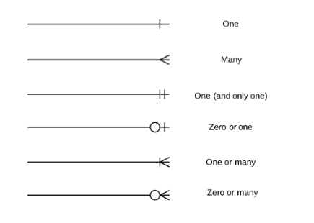
Figure 1: ERD diagram notation and symbols (Lucidchart. (2017).)

Now ERD diagrams are created for each of the normalization form which is explained in the above section. There are many CASE (computer – aided software engineering) tools available to draw ERD [4]. I have used ‘www.draw.io’ online tool to produce the below.

ERD for 1NF:
The below diagram shows the relationships between the entities identified in 1nf. As we see below one order consists of one or more products related because customer can place an order for more than one product at a time but at least one product should be included in any order. Here we have inserted an intersection entity called ‘Ordered Product’ to resolve the many to many relationships for products and orders. Also one product may be involved in zero or many orders as more than one customer can buy the same product.
Similarly when customer requesting for a quote there is no guarantee that customer will accept the quote price. But when the quote accepted then the order will be placed for that quote. So that’s the reason each quote can have zero or one order.
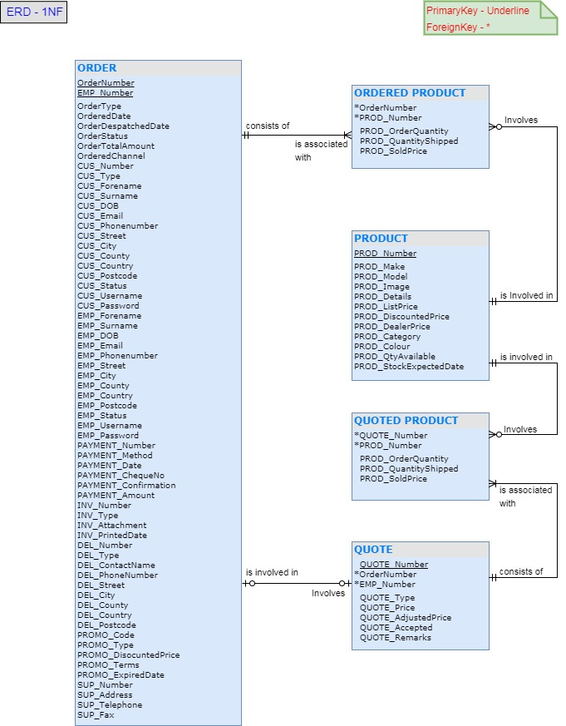

ERD for 2NF:
ERD diagram for 2NF is shown below and explanation also gives below.
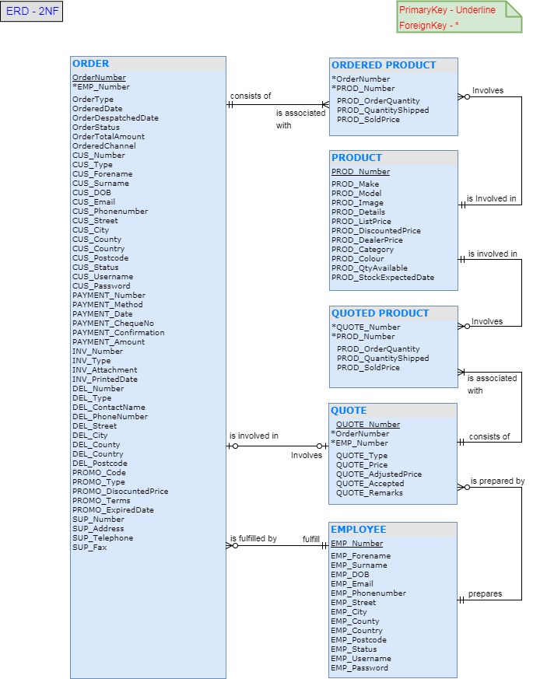
When compared to the 1NF only one change has been made in 2NF which is Employee table has been separated. Any order which is either online or telephone should be fulfilled by an employee only. Employee is the one who prepares the order with invoice and delivers to the customers. Employee also can make the orders to the suppliers. So Employee is mandatory for any order.
As we seen above in the ERD one order has related to one employee number. But zero or many orders can be fulfilled by employee. For example office staff only handles banking and other duties they don’t deal with any orders. So these employees can have zero orders related to them.
ERD for 3NF:
ERD for 3NF is shown below. This is final step that represents the entire information system required for new system.
In 3NF most of the entities get separated to individually represent a set of information about one object.
Firstly customer details are separated into CUSTOMER entity and intersection entity called Customer order has been created to map the orders with customer. As seen in the diagram customer can have zero or many orders but one order can be placed by only one customer.
Each order can only confirm after customer made the payment all the payment details have moved separate entity. Payment is unique to the order so it is one to one related to the order number.
Similar to the payment each order will have an invoice (receipt) so this is also one to one related with order entity. Order number is foreign key in Order Invoice table which uniquely identifies the order.
In the new system as we have got a new website will be created where customers can places orders online. So there should be a facility for the customer to place an order to the different delivery address for example customer will place order to his work address. So for this we have got new entity called delivery detail.
Similar to the above we have got promotion table which is used to store promo codes. As there is no mandatory for customers to have a promo code for each order it is one to one related in the case of customer using a promo code. But when there is no promo code involved no records will be inserted into Promotional order table.
At last all the supplier orders also treated as separate. Each supplier can have more than one order associated with him.
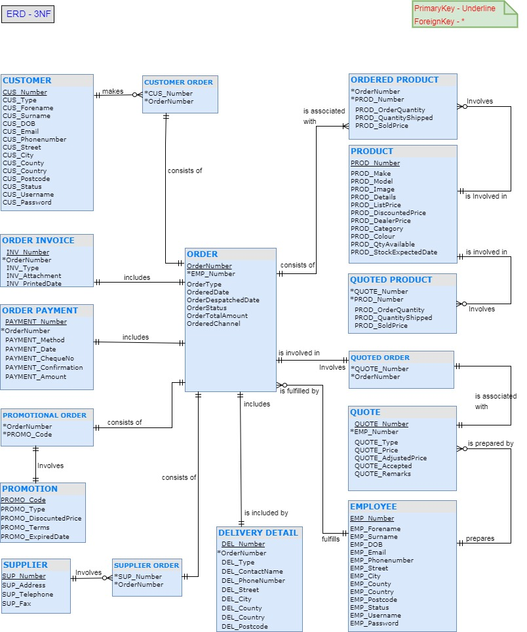

Task 4: Physical Process Model diagram
During the analysis phase we have created a logical data flow diagram (Level 0) with all the processes and data flows required for the existing system. The logical data flow doesn’t contain the information about how the new system works with the information system built. So physical process model is created base on Level 0 diagram proposed in the earlier assignment to know how the new system will work [1].

The physical process model also contains the same components from the Level 0 diagram. In addition to this it also contains some new data stores and processes required for the new system. There are some steps should be followed to created physical DFD as shown in figure 2.

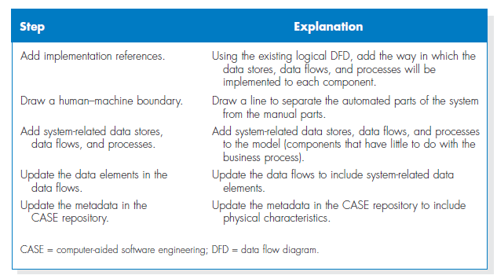
Figure 2: Steps to create physical data flow daigram (Dennis, A., Wixom, B. and Roth, R. (2015).)

Based on the above steps process DFD has been created below. The below steps followed to create the Physics DFD.

- Added the references to physical database table for each data store. For example website sales, telephonic orders will be stored in Order table.
- Added a human machine boundary to the all customers as all the orders need human customer and supplier interaction.
- Added additional process called Managerial reports which will used to generate daily sales order reports etc.
- Physical data elements are added to the all data flows.

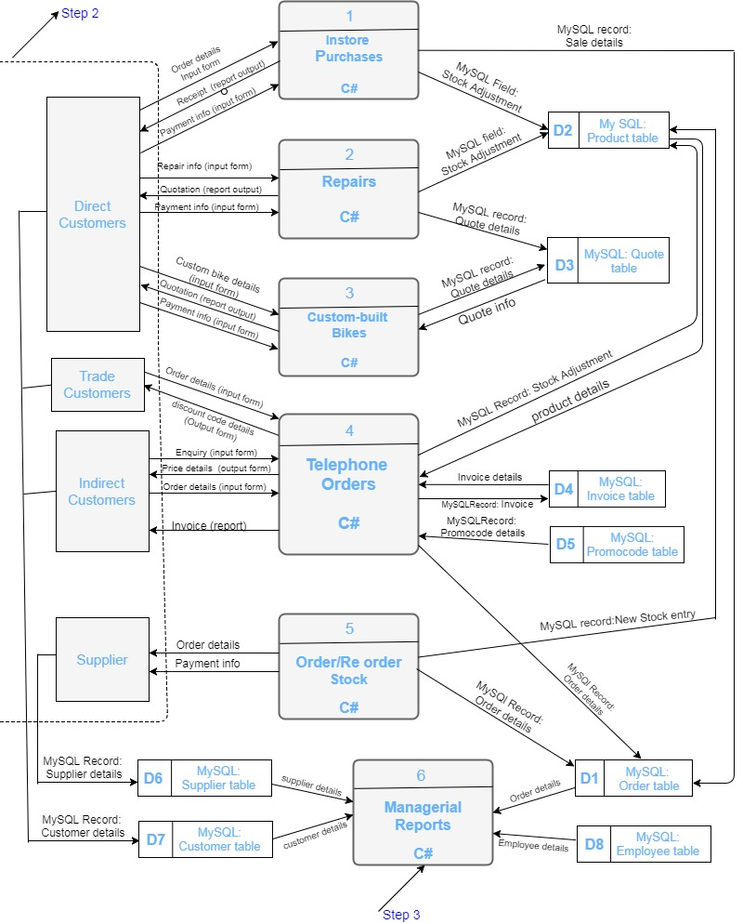

References

- Dennis, A., Wixom, B. and Roth, R. (2015). System analysis & design. 6th ed. Hoboken, NJ: Wiley.
- Anon, (2017). [online] Available at: https://www.slideshare.net/kosalgeek/database-normalization-1nf-2nf-3nf-bcnf-4nf-5nf [Accessed 4th Dec. 2017].
- Timlin.net. (2017). [online] Available at: http://www.timlin.net/csm/cis363/Normalization.pdf [Accessed 5th Dec. 2017].
- SearchCRM. (2017). What is entity relationship diagram? - Definition from WhatIs.com. [online] Available at: http://searchcrm.techtarget.com/definition/entity-relationship-diagram [Accessed 8 Dec. 2017].
- Lucidchart. (2017). Entity-Relationship Diagram Symbols and Notation. [online] Available at: https://www.lucidchart.com/pages/ER-diagram-symbols-and-meaning [Accessed 8 Dec. 2017]

